1. Install **Python** 3.8. 5

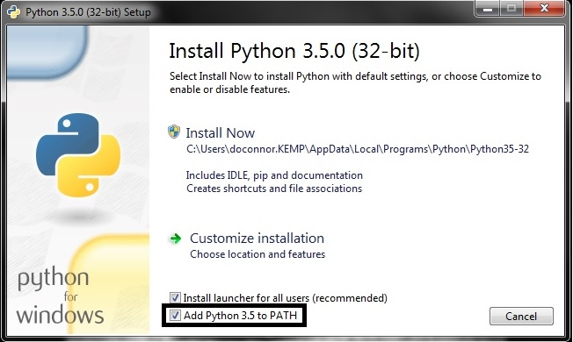

1. Install Visual Studio Code

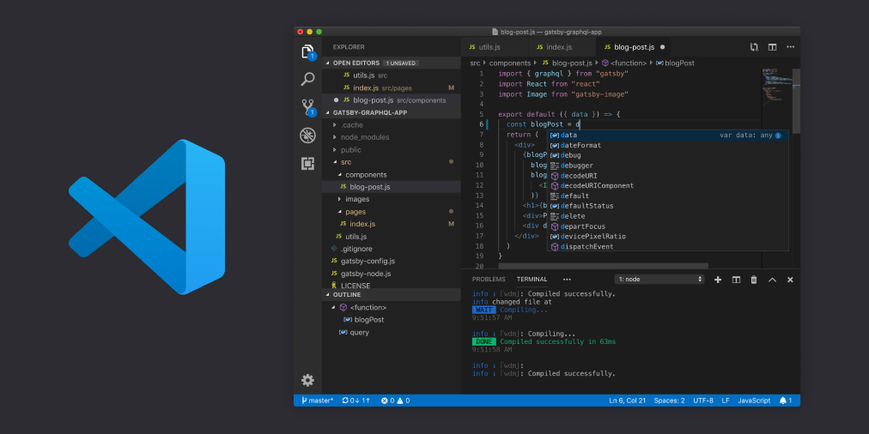

1. Open **cmd** command Prompt
2. pip install django

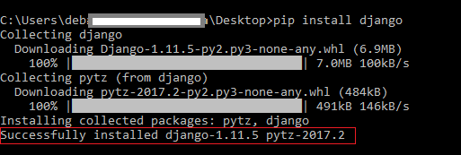

1. pip install pandas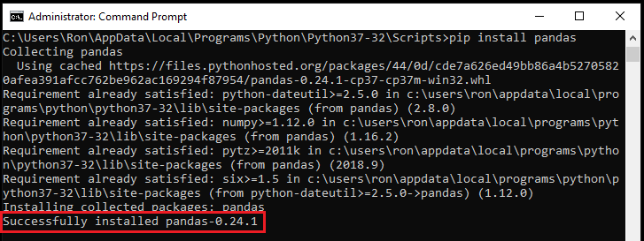
2. pip install matplotlib

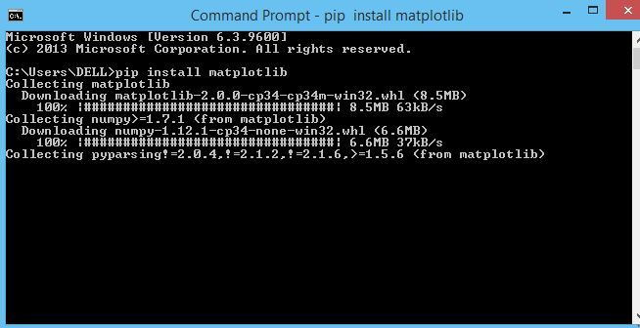

4) open settings of vs code and then search for :

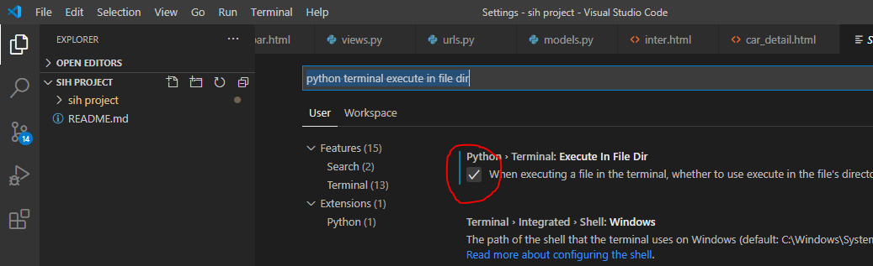 python terminal execute in file dir

5) open vmi directory in terminal and execute:

python manage.py runserver

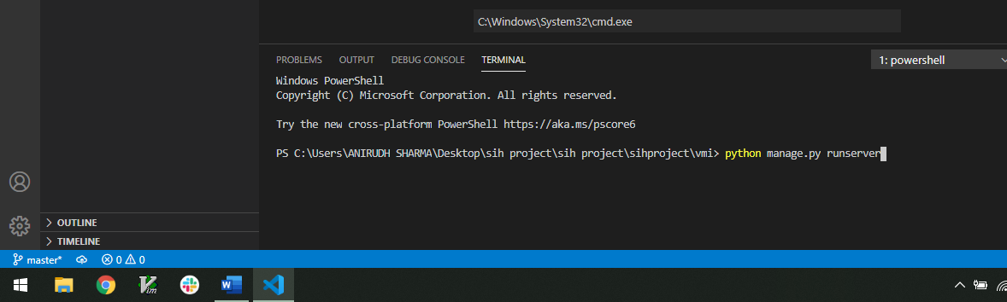Then ctrl+left click on localhost url

Remember to strictly type the above command in vmi directory only.

5) Username and Password of Admin Section:

Username: admin

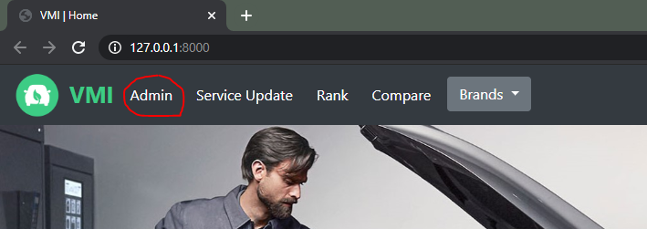 Password: admin

5) After doing service update run these two python files to generate new graphs and synchronise data

Directory of python files :

\sih project\sihproject\vmi\static\carprofiles

Files : Updater 1,

Updater 2

*they will take 2-3 minutes to run